Name: Aaron Rodriguez

Lesson 9: Insert and Update

1. **Create** a table with the following parameters:
   * CustomerID
   * CustomerName
   * Address
   * City
   * PostalCode
   * Country
   * Email

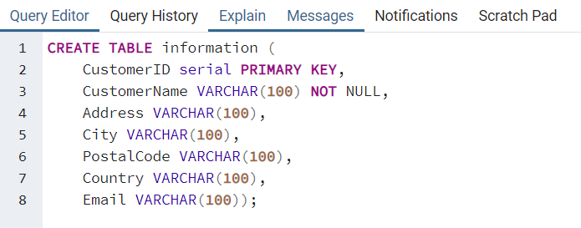



1. Insert 3 rows of data into these columns using **INSERT**. The data you insert should make sense for the column.



Command: INSERT INTO Customer_information(customername, address, city, postalcode,country,email)

VALUES ('Jim','180 Ralph Avenue','Brooklyn','12345','US','JimJones@email.com'),

('Joe','321 2nd Avenue','Detroit','11222','US','joeishere@email.com'),

('Steve','7345 Palm Street', 'San Francisco','11445','US','StephanSteve@email.com')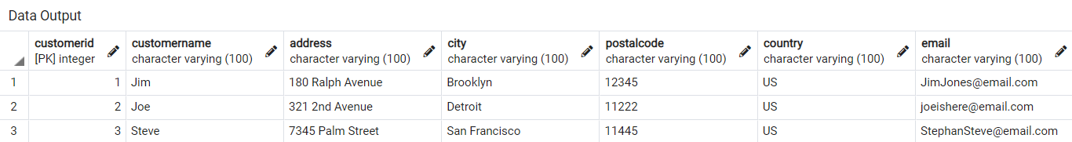

1. Use an **UPDATE** to modify any portion of the data

Command: UPDATE Customer_information SET city = ‘Chicago’ WHERE Customername = ‘Joe’

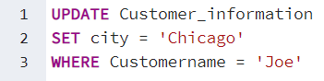

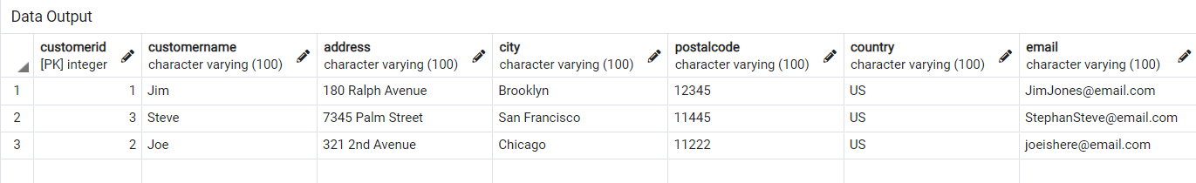

1. Finally, write a statement to **delete** one row of data.

Command: DELETE From Customer_information WHERE customerid = 2

